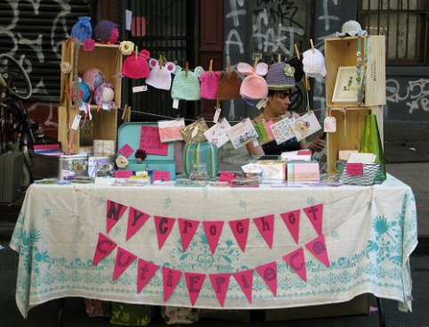
City of Virginia Beach
United Way
Craft Show Application
Saturday, July 15, 2017
10:00 am to 5:00 pm
Creeds Ruritan Club Community Complex
1057 Princess Anne Road
Virginia Beach, Virginia 23457

Crafter Information
Name________________________________________
Business Name________________________________
Address______________________________________
Phone________________________________________
Email________________________________________
Describe your craft in detail (This information will be used to eliminate duplication of crafts and space assignments. ________________________________________________________________________________________________________________________________________________
By completing this application, the applicant agrees to indemnify and save harmless the City of Virginia Beach from and against any and all loss, damage, claim, demand, liability, or expense by reason of any damage or injury to property or person which may be claimed to have arisen from or in connection to the use of premises for the Craft Show.

Space Assignment and Information
Each space is:
10’W X 10’L $60.00 ea. X___ Amount Due $___
($10 of this fee is paid to the City of Virginia Beach as a community event fee.)

Electricity Access - $5.00 (You will only have one outlet to use. Must bring extension cords and tape for safety precautions? Amount Due $___

6’Table Rental - $10 (Each booth area comes with 2 chairs) Amount Due $___
Total Due $______

This is fundraiser for the City of Virginia Beach United Way 2017 Campaign. All proceeds benefit the campaign and are non- refundable.

The City of Virginia Beach Virginia
2017 United Way Fundraising Committee
Craft Show

Will host a Craft Show on Saturday, July 15, 2017 at the Creeds Ruritan Community Center. Located in the beautiful rural setting of Virginia Beach, Virginia. Please join us in this worthwhile fundraising event! All proceeds benefit the 2017 United Way Campaign.
Exhibitors will be responsible for setting up, attending the show until it ends at 5 pm and cleaning up their booth area. We will have a limited amount of tables to rent. Your space will accommodate a 6’ or 8’ table. Early set up will begin on Friday, July 14, 2017 from 4:00-7:00 pm and again on Saturday, July 15, 2017 from 7:00-9:30 am. All booths should be ready to sell by 10:00 am. Please be sure to price all items as this makes a more pleasant shopping experience for everyone.
We are asking each vendor to donate an item from your booth for drawings during the day. Please have your donated item available by 10:00 am at the designated table.
There will be a limited number of spaces that have electrical access. You will need to bring your own extension cord and tape. All cords need to be taped down for safety.
The Creeds Ruritan and City of Virginia Beach United Way Fundraising Committee will not be responsible for damage to or theft from any booth or exhibit. Exhibitors must provide their own cash/change for customers. Please be aware that cell phone reception is not optimal inside this steel building. Credit Card transactions used on a phone may need to be taken outside for completion.
To reserve your space, complete the registration form with a check payment to the United Way. Please mail to:
Ellen Burns
c/o Pungo Blackwater Library
916 Princess Anne Road
Va. Beach, Va. 23457
** Attention United Way Craft Show**

For additional information contact:
Ellen Burns at 385-7792 or email at Eburns@vbgov.com.

